Module 7: Anpassungen an die konkreten Erfordernisse verschiedener beruflicher Felder und Arbeitsbereiche

09:00 – 12:00 (geschätzte Dauer: 3 Stunden)

Grundsätzliche Überlegungen:
Nachdem zum Auftakt (Modul 1) die Hauptprinzipien und Grundeigentümlichkeiten inklusiver Gesellschaften – sowie die Herausforderungen bei deren Umsetzung – erörtert wurden, war es das vorrangige Ziel des zweiten Abschnitts (Modul 2), einen möglichst klaren und gleichzeitig umfassenden, auf dem aktuellen Stand der Wissenschaft befindlichen Überblick über die Eigen- und Spielarten von Autismus-Spektrum-Störungen zu bieten. Und nach einer Einführung in das Konzept der Neurodiversität und dessen Implikationen für Autismus-relevante Belange verschiedenster Art (Modul 3), erfolgte schließlich der Schwenk in Richtung Praxis bzw. Anwendung und Vertiefung des bisher erworbenen Wissens. Dabei ging es in einem ersten Schritt um die Hinführung zu und die Einübung in praktische Hilfestellungen zur Kommunikation mit Menschen mit Autismus-Spektrum-Störungen, sowie um das Kennenlernen und Erlernen zusätzlicher sozialer Fertigkeiten, die den wechselseitigen Umgang und das Verständnis für- und miteinander zu erleichtern helfen (Modul 4). In einem weiteren Schritt wurden diese Fertigkeiten – und deren genau und individuell abzuwägender Einsatz – um weitere professionelle Einstellungen und Umgangsformen erweitert und ergänzt (Modul 5), ehe zum ersten Mal versucht wurde, all die erlernten Wissensinhalte und Instrumente zu einer Art Gesamtstrategie zusammenzufügen (Modul 6).

Im vorliegenden abschließenden Abschnitt wird es schließlich darum gehen, auf der Basis einer Wiederholung und Zusammenfassung der zentralen Parameter des Kurses konkrete Lösungen

für die spezifische Situation in verschiedenen Berufsfeldern und Arbeitsbereichen zu entwickeln. Es wird darum gehen, herauszufinden, was im jeweiligen organisationalen Umfeld möglich und gefordert ist, welche Elemente sich als praktikabel erweisen – und welche eher weniger –, und welche strukturellen Voraussetzungen – und eventuell Änderungen und Anpassungen – es dafür braucht. Und geschehen soll das anhand der gemeinsamen Erarbeitung von „Case Studies“, die in der Folge zur Diskussion gestellt und damit letztlich einer internen Evaluierung unterzogen werden. Nicht zuletzt damit soll die Kluft zwischen theoretischem Wissen und der Anwendbarkeit desselben endgültig ein gutes Stück weit geschlossen werden.

MODUL-PLAN

MATERIAL
- Computer
- Projektor/Beamer
- PowerPoint Folien
- Moderationskarten/Indexkarten
- Schreibtafel mit Kreiden oder Flipchart mit Marker-Stiften
- Notizbuch und Stift für alle Teilnehmer*innen
- Flipchart-Papier oder anderes Papier in Postergröße, Filzstifte, Marker
- Eine Kopie pro Teilnehmer*in für das Arbeitsblatt 1
- Eine Kopie pro Teilnehmer*in für das Arbeitsblatt 2
- Eine Kopie pro Teilnehmer*in für das Arbeitsblatt 3
- Eine Kopie pro Teilnehmer*in für das Arbeitsblatt 4
- Eine Kopie pro Teilnehmer*in für das Arbeitsblatt 5

ÜBERBLICK

Einleitung 09:00 – 9:30  - Ziele  - Inhalte  - Lernergebnisse  - Organisation  - Activity 1: Reflexion auf die vorangegangen Module | Erarbeitung 09:30 – 10:15  - Entwickeln und Entwerfen der Anpassungen  - Activity 2: Erheben und Sammeln notwendiger wie möglicher Anpassungen je nach spezifischem Berufsfeld und Arbeitsgebiet  - Activity 3: “So wird’s nicht gehen”  - Im spezfischen beruflichen Umfeld bereits vorhandene Richtlinien
10:15 – 10:45
Beak time
Develop 10:45 – 11:30  - Findings for your practice, implementation planning  - Activity 4: Summary of accommodations  - Activity 5: Implementation planning concrete  - Preparation of the posters for the presentation of the case studies | End 11:30 – 12:00  - Activity 6: “Vernissage”  - Goodbye

BEGIN
09:00 – 9:30
Aim, Contents, Learning outcomes
Organization
Activity 1: Reflection of the previous modules

#1. Welcome participants, introduce the aim, contents and the learning outcomes of this module
Note: Present slides number 1, 2, 3, 4, 5, 6 and 7
1 2 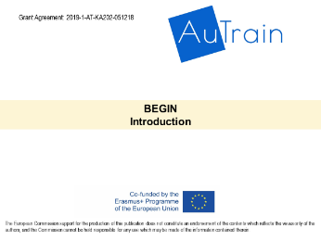3 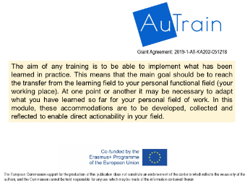
4 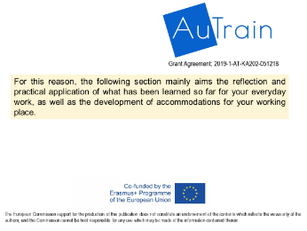 5 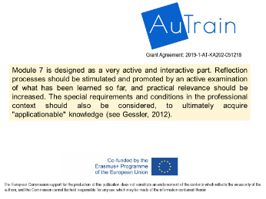 6 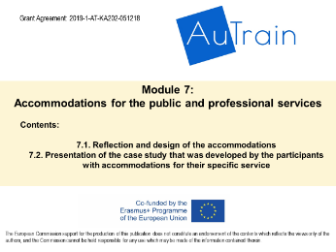
7 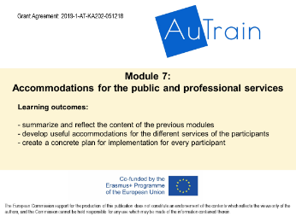
Aim:
This seventh module aims to reflect and develop accommodations that may be needed to satisfy the working environments of the participants.
Finally, the participants' case studies are presented and discussed.

Contents:
- Reflection and design of accommodations
- Presentation of the case study that was developed by the participants with accommodations for their specific service

Learning outcomes:
- To summarize and reflect the content of the previous modules
- To develop useful accommodations for the different services of the participants
- To create a concrete implementation-schedule for every participant

#2. Plan with participants break times comfortably throughout the module and about instruction adaptations, if needed
Note: Present slides number 8 and 9.
Organization:
Present the overview schedule of the session and suggest a 30 minutes break or two breaks of 10 minutes each. Let the group decide.
8 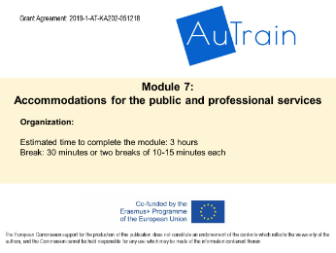 9 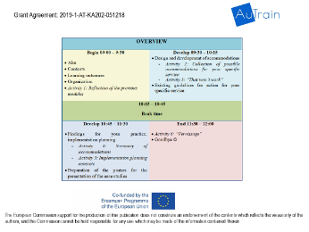
#3. Introduce and develop the Activity 1: Reflection of the previous modules
Note: Present slide number 10
10 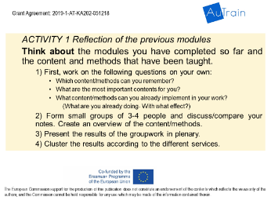
Aim of the activity: This activity aims to summarize and reflect the contents and methods of the previous modules. To make it easier to remember, worksheet 1 presents the headlines of the modules 1 to 6.

Introduce the material: Pass out the Worksheet 1

Procedures: Tell the participants to think about what they have learned so far and write down keywords. In a next step they should highlight those who were most important to them personally. Finally the participants should reflect on the content/methods/… they are already using in their work resp. what they are already practicing and or trying to do, and what kind of effects they could observe in regard to that use.
After about 8 minutes form small groups of 3-4 people and let them discuss/compare the notes. Create an overview of the content/methods by writing them on moderation cards and cluster them according to the different services of the participants.

DEVELOP
09:30 – 10:15

#4. Introduce and develop the Activity 2: Collection of possible accommodations for your specific service
Note: Present slides number 11 to 14

11 12 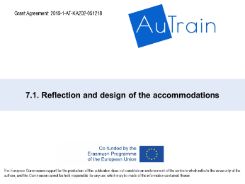 13 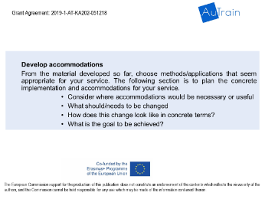
14 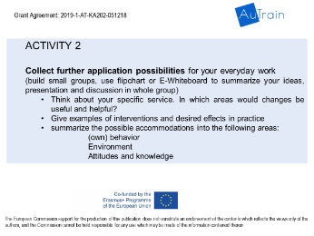
Aim of the activity: This activity aims to reflect the everyday work of the participants. They should identify areas in which changes are needed. In a further step, the participants should develop possible interventions and think about the effects they desire.
Slide 13 offers some questions for thinking about the topic before you get started with the activity.

Introduce the material: Pass out the Worksheet 2

Procedures: each participant works on this activity individually and writes his/her ideas on the worksheet. The possible accommodations should be assigned to 3 areas:
- (own) behavior
- environment
- attitudes and knowledge
Plan about 10 to 15 minutes for this activity

#5. Introduce and develop the Activity 3: “That won´t work”
Note: Present slide number 15
15 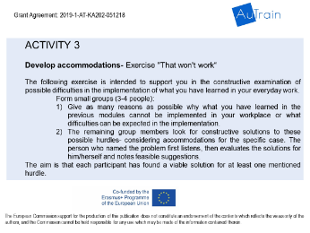
Aim of the activity: participants often think "that sounds good, but doesn't work for me". The following exercise serves to address these thoughts and to encourage a constructive examination of possible hurdles.
The following exercise is intended to support the participants in the constructive examination of possible difficulties in the implementation of what they have learned in their everyday work.

Introduce the material: Pass out the Worksheet 3

Procedures:
Form small groups (3-4 people)
In the groups the participants should find as many reasons as possible why, what they have learned in the previous modules cannot be implemented in their workplace, or what difficulties can be expected in the implementation process.
The remaining group members look for constructive solutions to these possible hurdles – considering accommodations for the specific case. The person who named the problem first listens, then evaluates the solutions for him/herself and notes feasible suggestions.
The aim is that each participant has found a viable solution for at least one mentioned hurdle.

#6. Online research: Look for further information
Note: Present slide number 16
16
After the activities the participants should do a short online research. You can decide whether each participant works on his/her own mobile phone or whether you do the research on the computer while projecting it to everyone. For the second route, a service is chosen in which most of the participants are active and an online search is started. This is only intended as a stimulus for further research and initiates the transition to the break.

BREAK TIME
10:15 – 10:45

DEVELOP
10:45 – 11:30
•Findings for your practice, implementation planning
- Activity 4: Summary of accommodations
- Activity 5: Implementation planning concrete
•Preparation of the posters for the presentation of the case studies

#7. #5. Introduce and develop the Activity 4: “Summary of accommodations”
Note: Present slides number 18 and 19
18 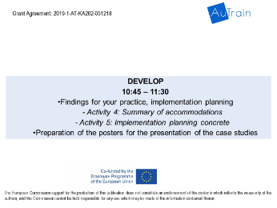 19 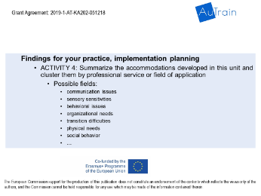
Aim of the activity:
In this section specific implementation options are worked out. We start with a collection of possible accommodations and organize them to create something like a “toolbox”. In the end, useful material for implementation should be available for each participant.

Introduce the material: Pass out the Worksheet 4

Procedures:
Form small groups (3-4 people) from similar services/ working fields.
In the groups the participants should summarize the accommodations developed in this module and order them by the different fields of application.
After that the groups present their findings in the plenum. The results should be written down on whiteboard or flipchart. Make photos to share them with the participants for further use.

#8. Introduce and develop the Activity 5: Implementation planning concrete
Note: Present slide number 20
20 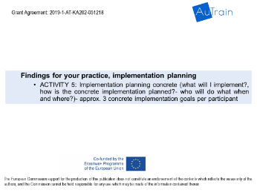
Aim of the activity: In this activity, the participants should plan concrete implementations for their work. This should support the transfer into everyday life, have a binding effect and create clarity.

Introduce the material: Pass out the Worksheet 5

Procedures: Each participant works on this activity individually and writes his/her ideas on the worksheet.
After that form small groups (3-4 people). In the groups everyone should present at least one planned implementation. The group members should be motivated to ask questions so that the participants can formulate their plans as concretely and clearly as possible.

In the end ask the whole group for comments, doubts, or questions.
#9. Introduce the second section of the module- presentation of the case studies
Note: Present slides number 21 to 22
21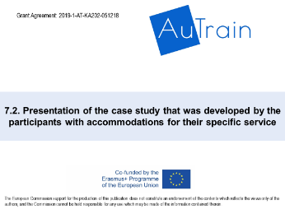 22 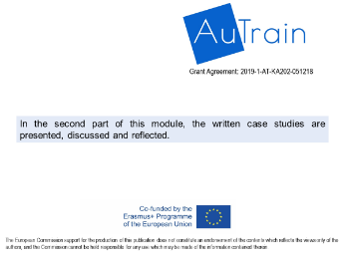 23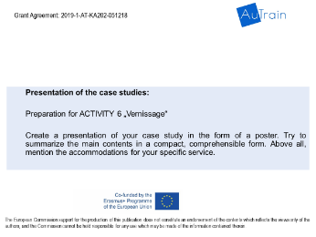
Procedures:
Hand out paper in poster size or flipchart paper, as well as pens in different colors to the participants.

Every participant should create a presentation of his/her case study in the form of a poster. They should try to summarize the main contents in a compact, comprehensible form. Above all, accommodations for their specific service should be mentioned.

END
11:30– 12:00
•Activity 6: “Vernissage”
Questions? Goodbye & thanks
#10. Activity 6: “Vernissage”
Note: Present slides number 24
24 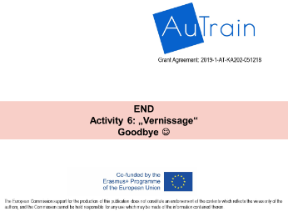 25 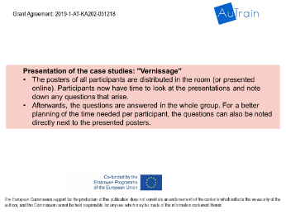
The posters of all participants are distributed in the room (or presented online). Participants now have time to look at the presentations and note down all the questions that arise.
Afterwards these questions are discussed and answered in the whole group. For a better planning of the time needed per participant, the questions can also be noted directly next to the presented posters.
Make photos of the posters to share them with the participants for further use.

After that ask for final comments, doubts, or questions.

#11. Questions? Goodbye & Thanks for coming
Ask for any question participants may have.
Note: Present slide number 26
26 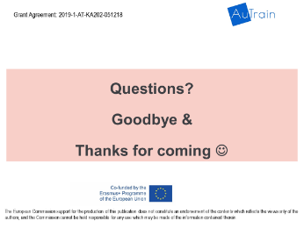
End of the module

